* **BREAKING**



Shaded M… Larrge Sha… Small Sha… Cuttaway --… Warrm Sha…

Blue Gradient Trrii......

Sample Pa… Armor Sla… Cayman Sll… Emerald Sl… Cyclops Ac…



No arrest in second killing

**Mattapan man arrested in first**

**Boston homicide of 2014**

**By Wesley Lowery and John R. Ellement** Globe staff, January 10, 2014, 8:59 a.m.

Red Sox 10, Braves 8, Final

**6**



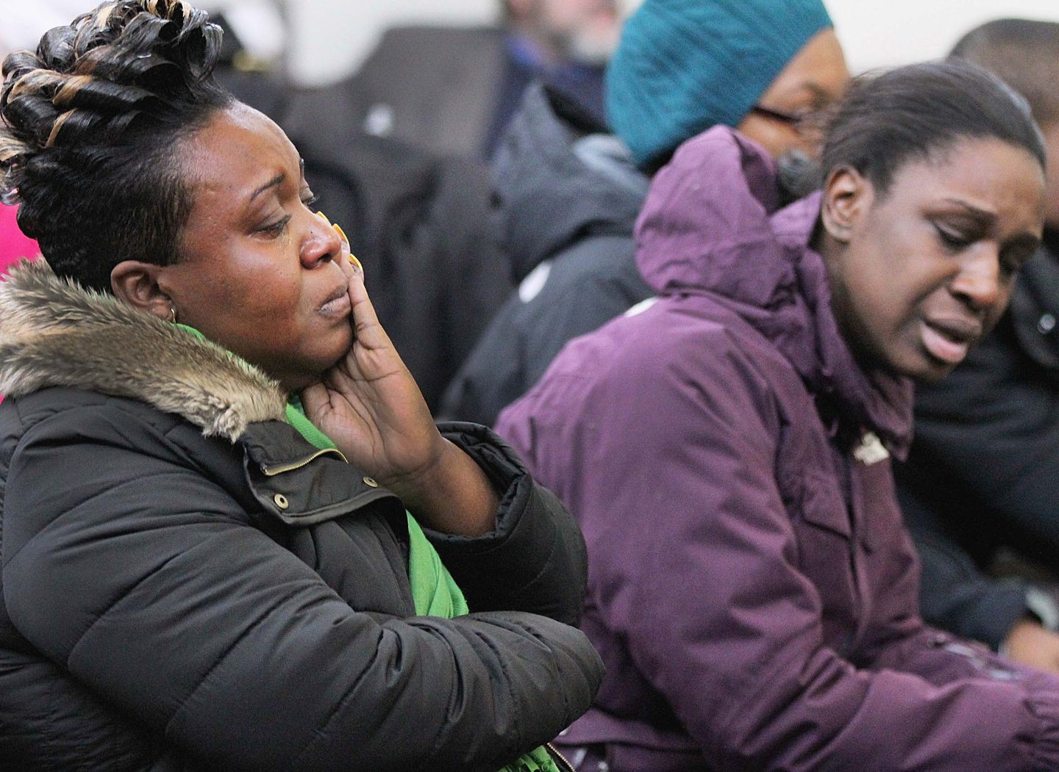

Friends and relatives of homicide victim Samuel Constant attended the arraignment in West Roxbury of William Earl, who authorities believe had a dispute with the deceased. WENDY MAEDA/GLOBE STAFF

Samuel Constant was the first person killed in Boston this year, but as his family awaited the beginning of proceedings in West Roxbury Municipal Court Friday, they still did not believe that he was gone.

Their doubt turned to rage as the court clerk read the murder charge against William Earl of Mattapan. Some of Constant’s family members sobbed; one stormed out.

Prosecutors said Earl, 20, stabbed Constant, 19, outside a Hyde Park home around dinnertime Thursday, but provided no motive.

Earl stood behind the courtroom door Friday morning as his lawyer entered a not guilty plea on his behalf. Earl’s face was shielded from the tear-filled eyes of roughly two dozen family members and friends of Constant who sat in the crowded courtroom.

Advertisement

**BOSTON GLOBE VIDEO**

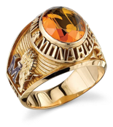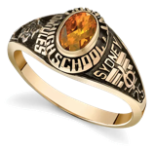

2:23

Baker announces ‘VaxM SHARE

Governor Charlie Baker announced residents who are

fully vaccinated against COVID-19 will have the chance to win $1 million in a special Lottery sweepstakes. (Photo by Matt Stone/Boston Herald via AP)

“My nephew is dead, and the guy who did it won’t even show his face,” said Constant’s uncle Gerome Abner, 41, of Roxbury, who attended the hearing and spoke to the Globe afterward. “We came here for answers, and we still don’t know anything. All we know is that he’s dead.”

**s ns’**

**rd**

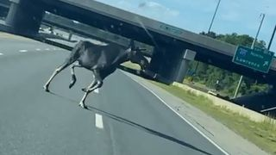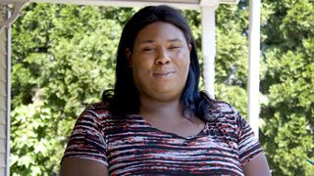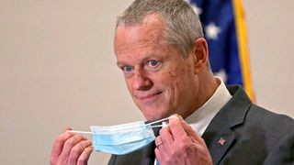

**Baker Moose What announce spotted Black ‘VaxMillio on liberation lottery Route 3 means program in to me:**

**Chelmsfo Athena**

**Vaughn**

**NOW PLAYING**

**Get Today's Headlines in your inbox**

The day's top stories delivered every morning.

Enter Email

[example@email.com](mailto:example@email.com)

**Sign Up**

Police said the two men were believed to have been acquainted. A law enforcement official with knowledge of the investigation, speaking on the condition of anonymity, said investigators are looking into whether the stabbing was related to a love interest.

Family members said they did not know Earl and



Boston Police at the scene of a fatal stabbing that took place Thursday evening on Margaretta Drive in Hyde Park. WENDY MAEDA/GLOBE STAFF

were unsure of what the motive might be for the alleged killing, which they said occurred near Constant’s girlfriend’s home.

A witness told responding officers that the attack was unprovoked, although police said Earl and the victim had engaged in a heated argument around 6

**MOST POPULAR ON BOSTONGLOBE.COM**

1. A treasure map for an American tyrant
2. Baker announces ‘VaxMillions’ lottery program, offering $1 million cash prizes to boost vaccination rates
3. 5 things to know about the VaxMillions lottery sweepstakes in Mass.
4. America's blind spot: Thousands of drivers shouldn't be licensed
5. Death penalty should be reinstated for Tsarnaev in Boston Marathon bombings case, Biden administration tells Supreme Court
6. Message in a bottle, tossed into the sea in Rhode Island, found in Azores
7. The downside of ditching masks: the return of colds, flu
8. How white supremacy weaponizes ignorance
9. I got the Johnson & Johnson vaccine. The pause makes me believe in it more.
10. A Milton gay couple was harassed anonymously for years. Then a piece of handwriting unraveled the mystery

p.m. outside 139 Margaretta Drive. The victim, who also lived in Hyde Park, was pronounced dead at the scene, and Earl suffered minor injuries, police said.

Earl acknowledged the attack to witnesses at the home, according to the police report, and later asked police if Constant was dead.

Advertisement

According to the report, another witness told police that Earl said, “I killed someone, and that’s what you’re going to find.”

Later, when questioned by an officer, Earl asked about Constant, saying, “I just want to know if he’s dead.”

At the scene Thursday night, a 21-year-old woman said she had heard part of the exchange that led to the fatal stabbing.

“It sounded like people were fighting or arguing, and then I got scared and I didn’t hear anything else,” she told the Globe.

She and a friend said that later they saw a body covered by a sheet in a parking area, with two knives and a patch of blood visible on the pavement.

Assistant District Attorney Tara Burdman successfully petitioned that Earl be held without bail. His next court date was set for Feb. 10.

At the end of Earl’s arraignment, Constant’s mother stood bolt upright, letting out a pained shriek. She continued to scream as more than a dozen family members escorted her outside.

“Whoa, my baby!” the mother screamed. “I want to see him!”

About five hours after Constant was stabbed to death, a man was shot several times at 136-138 Rowe St. in Roslindale and pronounced dead at the scene, Superintendent in Chief William Gross of Boston police said Thursday night.

Gross said police have no description of the suspect in the Roslindale case, and police said Friday that authorities had no indication that the shooting was linked to the earlier stabbing.

Advertisement

The first and second homicides of the year happened the same day Mayor Martin J. Walsh named William Evans as the city’s new police commissioner and that Evans, in turn, named Gross as his second in command.



**VIEWS FROM OUR COLUMNISTS**

**YVONNE ABRAHAM**

Energy efficiency is a low- hanging fruit to combat climate change. So why can’t everyone get access to it?

**KEVIN CULLEN**

Bill Bratton on American policing and the challenge facing the Boston Police Department

**THOMAS FARRAGHER**

A salute across the ages to an old squad leader

**SHIRLEY LEUNG**

A working mother’s manifesto: Pandemic provides a once-in-a- generation chance to course correct how we work

**JENEÉ OSTERHELDT**

Juneteenth and the meaning of Black liberation in Boston

**ADRIAN WALKER**

‘The best Boston movie no one’s ever seen’: ‘Blue Hill Avenue’ at 20

There were 40 homicides in Boston in 2013, with the first occurring in Allston at a New Year’s Eve party in the early hours of Jan. 1.

[Wesley Lowery can be reached at wesley.lowery@globe.com. Follow him](mailto:WesleyLowerycanbereachedatwesley.lowery@globe.com.Followhim) [on Twitter @WesleyLowery. John R. Ellement can be reached](mailto:onTwitter@WesleyLowery.JohnR.Ellementcanbereached) [atellement@globe.com. Follow him on Twitter @JREbosglobe.](mailto:atellement@globe.com.FollowhimonTwitter@JREbosglobe)

**Show comments**

**MORE ON GLOBE.COM**

**PROVIDED BY: PHILIP MORRIS INTERNATIONAL**

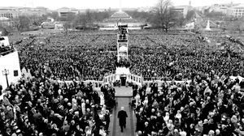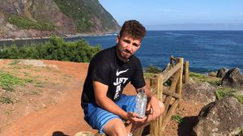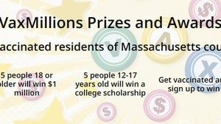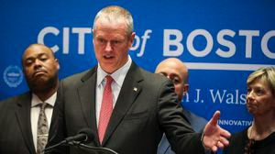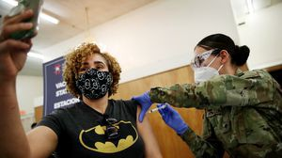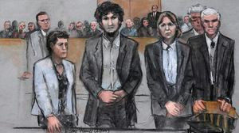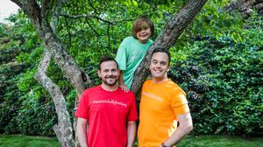

**Is a future without cigarettes within reach?**

This company has a team of more than 400 scientists and R&D experts working on smoke-free alternatives.

**A treasure map for an American tyrant**

Donald Trump exposed weaknesses that a would-be dictator could exploit to end our democracy. It’s now up to lawmakers, voters, and public officials to prevent that from happening.

**RI NEWS**

**Message in a bottle, tossed into the sea in Rhode Island, found in Azores**

The note was written in 2018 by a 13- year-old who was visiting family in Rhode Island.

**Baker announces ‘VaxMillions’ lottery program, offering $1 million cash prizes to boost vaccination rates**

State officials on Tuesday said residents who are fully vaccinated against COVID-19 will have the chance to win $1 million in a special Lottery sweepstakes.

**Future-proofing the Presidency** Donald Trump brought our democracy to the brink and exposed its weak spots. How to thwart the next American tyrant.

**Study says COVID-19 was likely present in Mass. as early as December 2019**

The federal National Institutes of Health said it had found evidence that the coronavirus was in Massachusetts and four other states far sooner than previously thought.

**5 things to know about the VaxMillions lottery sweepstakes in Mass.**

Here are five things you should know about the VaxMillions program, which will make some lucky winners living proof that trusting the science really does pay.

**Death penalty should be reinstated for Tsarnaev in Boston Marathon bombings case, Biden administration tells Supreme Court**

The Biden administration is asking the Supreme Court to reinstate the death penalty against Dzhokhar Tsarnaev for the Boston Marathon terror bombings.

**A Milton gay couple was harassed anonymously for years. Then a piece of handwriting unraveled the mystery**

After years of dead ends, police recently were led to a suspect, a neighbor who lives a few doors from the couple and had shared hellos, waves, and casual conversation with them.

**America's blind spot: Thousands of drivers shouldn't be licensed** A Boston Globe investigation of how bureaucratic negligence has left lethal drivers on the road.

**METRO SPORTS BUSINESS & TECH OPINION**

WELCOME, JOHN

**TODAY'S PAPER**

**Check out this week's**

**virtual events**

RSVP now

**LAWMAKERS STRIKE DEAL TO RESTORE PANDEMIC-ERA POLICIES, INCLUDING EVICTION PROTECTIONS, TO-GO COCKTAILS**

**MOST READ IN THIS SECTION**

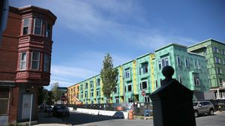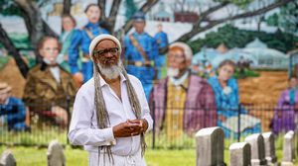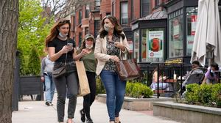

**RI NEWS**

**Message in a bottle, tossed into the sea in Rhode Island, found in Azores**

**America's blind spot: Thousands of drivers shouldn't be licensed**

**Baker announces ‘VaxMillions’ lottery program, offering $1 million cash prizes to boost vaccination rates**

**Study says COVID- 19 was likely present in Mass. as early as December 2019**

**A Milton gay couple was harassed anonymously for years. Then a piece of handwriting unraveled the mystery**

**With housing at center of Boston mayor’s race, labor and developers are organizing to push candidates**

**How Massachusetts communities are celebrating the state’s first official Juneteenth**

**5 things to know about the VaxMillions lottery sweepstakes in Mass.**

**The downside of ditching masks: the return of colds, flu**

**FOLLOW US**

**SUBSCRIBE NOW MY ACCOUNT CONTACT MORE**



Digital Access Home Delivery

Gift Subscriptions

Log In

Manage My Account Customer Service

Help & FAQs Globe Newsroom

Advertise

Newsletters / View The EPaper /

Order Back Issues / News In Education / Search The Archives / Privacy Policy / Terms Of Service / Terms Of Purchase / Work At Boston Globe Media /

Do Not Sell My Personal Information

©2021 Boston Globe Media Partners, LLC